**INTRODUCTION**

**OVERVIEW**:

> Smart Parking is a parking solution that can include in-ground Smart Parking sensors, cameras or counting sensors. These devices are usually embedded into parking spots or positioned next to them to detect whether parking bays are free or occupied. This happens through real-time data collection. The data is then transmitted to a smart parking mobile application or website, which communicates the availability to its users. Some companies also offer other in-app information, such as parking prices and locations. This gives you the possibility to explore every parking option available to you.

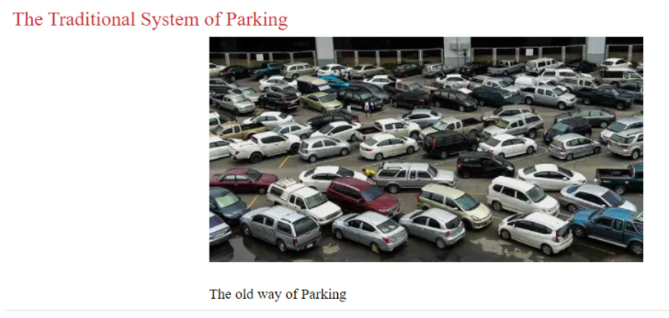

> Smart Parking and its Smart Parking Sensors can be seen as a part of smart cities. These smart cities are cities that are driven by an IT infrastructure and by using this infrastructure, cities can enhance the quality of life and improve economic development for its inhabitants. Becoming a smart city can be a good way to collect historical data in a relatively easy way. By collecting this data, cities can analyse how processes, like parking can be optimized.

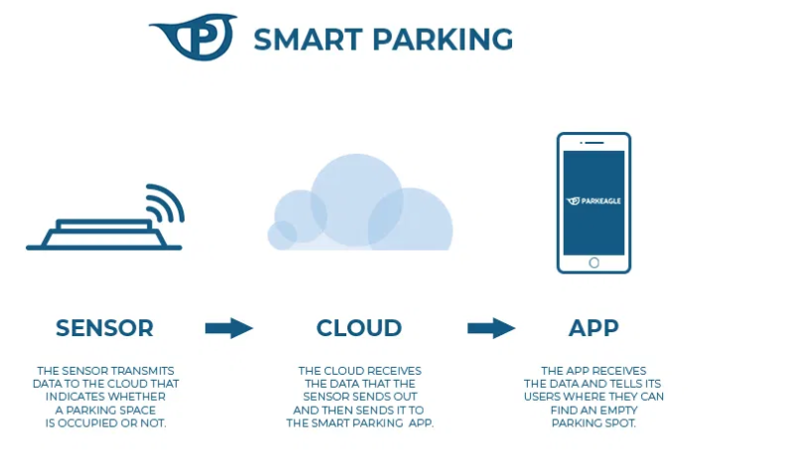

> As a result of using Smart Parking, people who are looking to find a parking spot will find it in the most efficient way possible and companies or municipalities can optimize their parking territories. It also makes cities more liveable, safer and less congested

**PURPOSE**

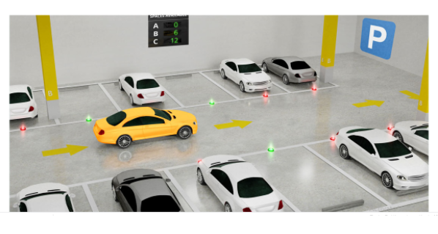

Naturally, this results in **congestion** around the **parking venue**. In INDIA, the drivers spend an average of 80 hours per year looking for parking. We are literally wasting days stuck in traffic, looking for a place to park.

However, creating more **parking spaces** won’t necessarily solve traffic congestion in densely populated cities. Instead, we need better management of the existing spaces. **Smart parking technology** holds the key to easing traffic by smoothening parking process for both drivers and operators.

**LIERATURE SURVEY**

>**Existing problem**

### **Inefficient Parking Management Worsens Traffic :**

Smart parking isn’t about creating more parking spaces but making it easier for drivers to quickly locate existing ones such that time spent on the road is significantly reduced. Drivers cruising around a parking lot worsen traffic since they drive slower than those that aren’t looking for parking.

Moreover, drivers cruising around parking spots are more likely to get into an accident; about one in every five traffic accidents occurs in or around a **parking lot**. It isn’t hard to imagine distracted drivers accidentally colliding with other vehicles. This also puts pedestrians at risk. And once an accident happens, it further delays the flow of traffic since moving a damaged vehicle off the road takes time.

### **Smart Parking as a Solution to Traffic Woes :**

Smart parking technology combines the use of **sensors**, street lights, **smart navigation systems**, and **online payment platforms** to relay information to drivers and **parking lot operators**. The **real-time data** collected from the sensor system is translated into actionable insights on smart parking applications. These are then used by drivers to take the least congested route, get an overview of the parking options, and make payment at the touch of a button.

### **Smart Parking Eliminates Distractions:**

Smart parking can reduce traffic by making it easier to locate empty parking spaces, thus lowering the risk of distracted driving. Through the use of sensors that detect whether space is empty or occupied and lights that indicate this, smart parking technology can help drivers locate spots. Rather than scan for empty spaces, drivers can easily assess availability through red and green lights. This would also help them plan their **parking maneuver**, warning the driver behind that they are going to pull into space.

### **Smart Parking Reduces Cruising Time :**

Smart parking also reduces traffic congestion by making the process of parking faster. If city planners installed sensor lights on every space, drivers could get off the road quickly by understanding availability in advance. Parking facilities can also list the number of spaces available at the entrance with sensors constantly updating the figures, thus ensuring drivers always have the latest information and save commute time.

Smart parking technology can go even further than sensors and lighted spaces. Using the latest advances in **IoT**, sensors can be synced to a **cloud platform** that feeds the information into a **mobile app**. Such apps could then guide the driver with a GPS providing directions to the next available parking space. Thus, the driver can keep their eyes on the road and save time looking for spaces.

Another way smart parking can ease traffic is by making payment easier. Smart parking apps allow instant payment through smartphones, this making a parking space available to the next driver quicker.

**EXISTING PROBLEM**

The main existing problem is the traffic jam that occurs in the urban areas which are caused by vehicles searching for parking.

**PROPOSED SOLUTION**

We proposed an automated system where the user can check for free slots before arriving there by a website. It will save the time as well as reduce the gathering in front of parking area.

**BLOCK DIAGRAM**

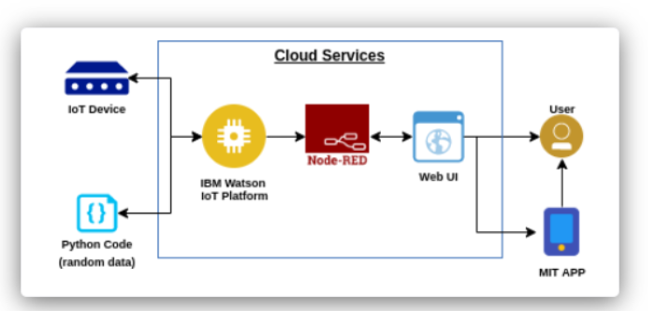

**HARDWARE/SOFTWARE DESIGNING**

Python IDLE, IBM IOT Platform, Nodered (Platform Service),MIT Al Companion.

**EXPERIMENTAL INVESTIGATIONS**

The proposed system is the combination of smart parking and the Slot allocation with the web application.

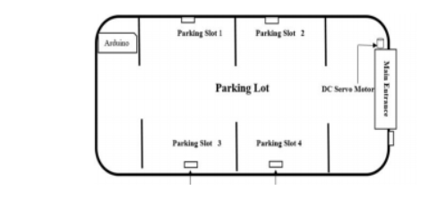

Above diagram shows the modular representation of the automated car parking slots. Here four (this number can be changed according to the demand of parking slots) have been showed where ultrasonic sensors are placed. A DC servo is connected with the main gate to make it opened or closed. Out side the main entrance there is an ultrasonic sensor to sense the presence of a car which is trying to make entrance inside the parking slot.

As soon as the sensors get the presence of a car in front of the entrance, it will send signal to check if there is an empty slot inside the parking lot. When it gets acknowledged that there is an empty slot or more then it will send signal to the dc servo motor which will open the main entrance. On the other hand, if there are no empty slots at the time of a car trying to make entrance, the gate will just not open. In addition, there will be a website linked with the MIT app to show the number of parking slots remaining empty.

RESULT

The proposed parking system will work automatically using the software provided in such a way that it can solve parking problem to most extent.

**ADVANTAGES:**

Optimized parking Reduced traffic

Reduced pollution Enhanced User Experience

New Revenue Streams increased Safety

Real-Time Data a Decreased Management

Increased Service

**DISADVANTAGES:**

Cost of the system is more

Complexity of the design increases

System allows one by one parking

Addition of security features to protect user privacy

**APPLICATIONS :**

Apartments

Theatres

Shopping malls

Function halls

Companies

Hotels

Educational institutions

Cricket stadium

**CONCLUSION**

After doing study on smart parking project it is found that this system can be introduced in our country and it will be beneficiary in the context of our country. It provides security to the parking grounds. It reduces the hassle in parking grounds and traffic jam. It will also encourage Automation Engineering in our country which will make advancement in increasing usage of technology. Therefore, we should implement this project and help to develop our city.

**FUTURE SCOPE**

The smart parking industry continues to evolve as an increasing number of cities struggle with traffic congestion and inadequate parking availability. While the deployment of sensor technologies continues to be core to the development of smart parking, a wide variety of other technology innovations are also enabling more adaptable systems—including cameras, wireless communications, data analytics, induction loops, smart parking meters, and advanced algorithms.

**BIBLIOGRAPHY**

<http://www.ijaceeonline.com/ARCHIVE/IJACEE_FPV4I1P2.pd>

**APPENDIX**

**SOURCE CODE :**

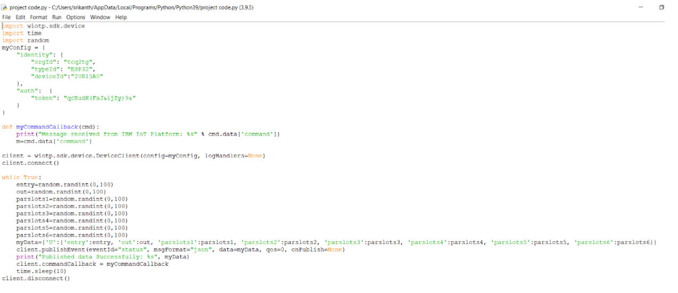

**UI OUTPUT SCREENSHOT :**

